Two Rhythms Case Study: E’s Story –
Two Rhythms provides cross-sector and multi-disciplinary support into life-long learning through Music and Movement, autonomy and self-expression
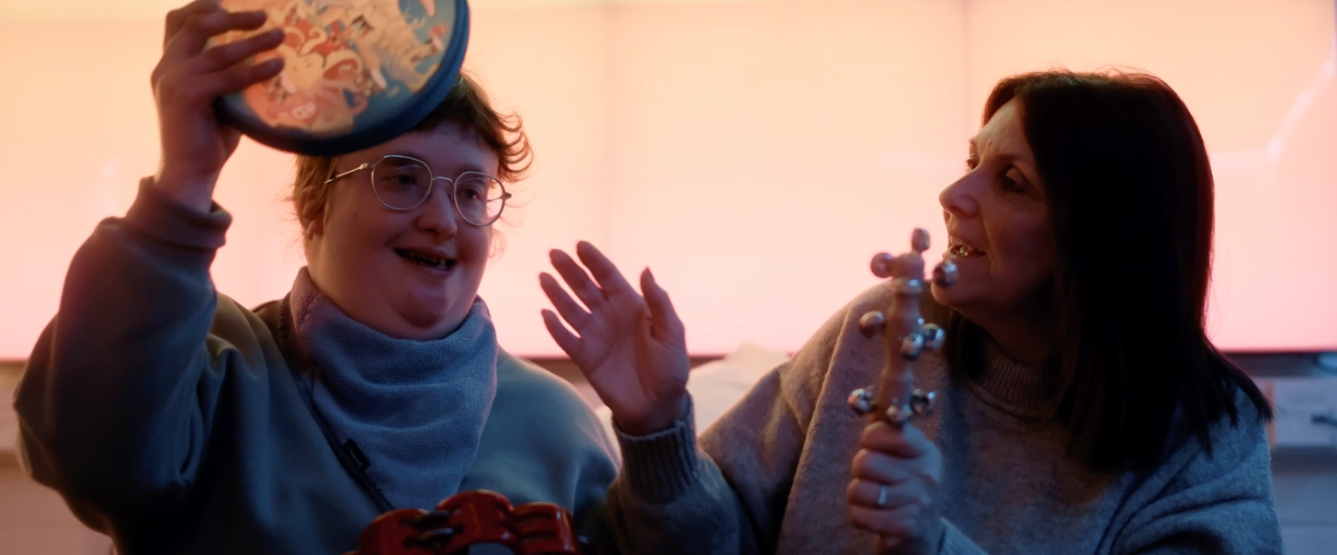

Background
Emily is a happy and giggly 22 year old who is diagnosed with Mowat Wilson Syndrome, a genetic condition which affects many parts of the body. Emily also has additional needs, is non-verbal and needs assistance with her personal care.
Emily loves to laugh and socialise, and likes to be out and about and enjoys meeting up with friends and family. She also loves swimming in her pool and can float about with her noodle. She enjoys kicking her legs in the pool and using her arm to splash everyone!
Previously, Emily attended Two Rhythms sessions at SEN school, through Two Rhythms / previously Touch Trust Membership Organisation programme. During the pandemic Emily had regular online sessions, where she enjoyed still being able to connect with her friends and socialise.
Emily also regularly takes part in different projects with Two Rhythms, most recently enjoying the poetry project, where she worked on the weather and different seasons, using different props to engage with the sessions. She thrives on having a various opportunity for life-long learning through arts.

Attendance at Two Rhythms
She currently attends sessions at the centre twice a week, once for a 121 session, and once for a group session. Emily attends Two Rhythms with her personal assistant Julie, who has been bringing her for the past 4-5 years.
Emily can be a bit shy at the start if she is unsure of someone, however once she gets to know them and feels comfortable she engages and interacts much more. Emily has worked with many different facilitators, and has built her confidence with many of them over time. Julie, Emily’s personal assistant, thinks Emily’s favourite is Viv though!

Understanding and engagement with Two Rhythms sessions
Having attended for many years, Emily now shows a clear understanding of the structure of her Two Rhythms sessions, for example rubbing her hands together when it is time to begin energy stroking. She will also indicate clearly when she is ready to move on to the next section by clapping her hands.
Emily engages with all aspects of the session, especially enjoying the stretching and movement, music, and dancing. She makes good eye contact with the session leader once she is comfortable and enjoys supporting her peers when in a group session. Emily is most engaged however during percussion when we use the musical instruments.

Musical confidence, choice making and expression
Emily is building her confidence with lots of new instruments, and over time has started making more choices about which instruments she would like to play, and how she would like to play them.
In particular, Emily has been enjoying developing her skills on the xylophone. Previously, Emily would only play with one beater, playing brief notes which large spaces in between playing. As she has got more confident, Emily has recently started to play using two beaters and both hands. She also plays much more consistently and for longer periods of time in one go.
Emily is translating this skill onto other instruments, and starting to use both hands to play the drums, and to hold shakers in each hand too. She now lifts her arm up to shake bells and the ocean drum, which she will do when prompted. She has also been moving the ocean drum to different hands. She also likes to bang the ocean drum to make a loud sound, which she finds very funny.

Enjoyment
The most notable thing about Emily’s Two Rhythms sessions are how much she enjoys them. Emily is always so smiley in sessions, and her infectious laugh means we all leave smiling too. It is noticeable how as Emily builds up trust with a session leader, she is able to relax and enjoy the session more, which allows her to try new things. Even during virtual sessions during the pandemic, Emily was always laughing and smiling- particularly enjoying doing a huge full body stretch, leaning back on her beanbag and kicking her legs in the air.

What is next?
As Emily continues to attend Two Rhythms on a regular basis, we will continue to encourage her to make her own choices and to express herself using different instruments and sounds. Emily’s enjoyment in learning new skills is evident and her continued development with her motor skills using both her hands such as playing different instruments may soon be observed. We are privileged to witness Emily continuing to thrive and learn through art of movement and music.
“Two Rhythms support is amazing. It brings lots of joy to Emily... Once she builds up that trusting relationship, Emily thrives on it then... She just absolutely enjoys it every time.” Julie PA

